**SQL Homework – 01** Fani Shundovska

1. **Write a *query* to select all the customers that have contact title Sales Agent*.***

*-- zadaca 1 - prasanje 1*

**SELECT** *

**FROM** customers

**WHERE** ContactTitle='Sales Agent';

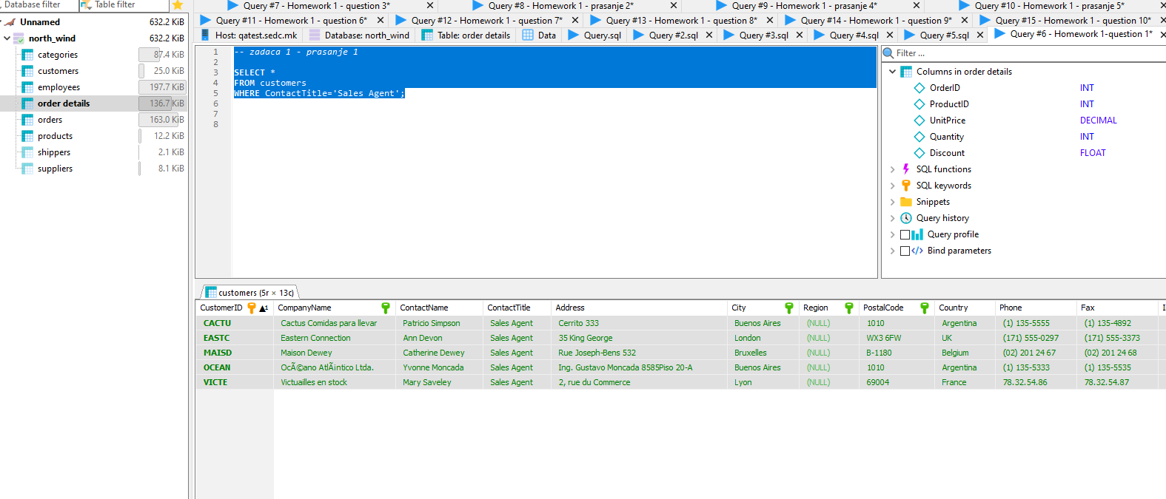

1. **Write a *query* to select all the customers that have region different than NULL.**

*-- zadaca 1 - prasanje 2*

**SELECT** *

**FROM** customers

**WHERE** Region !='(NULL)';

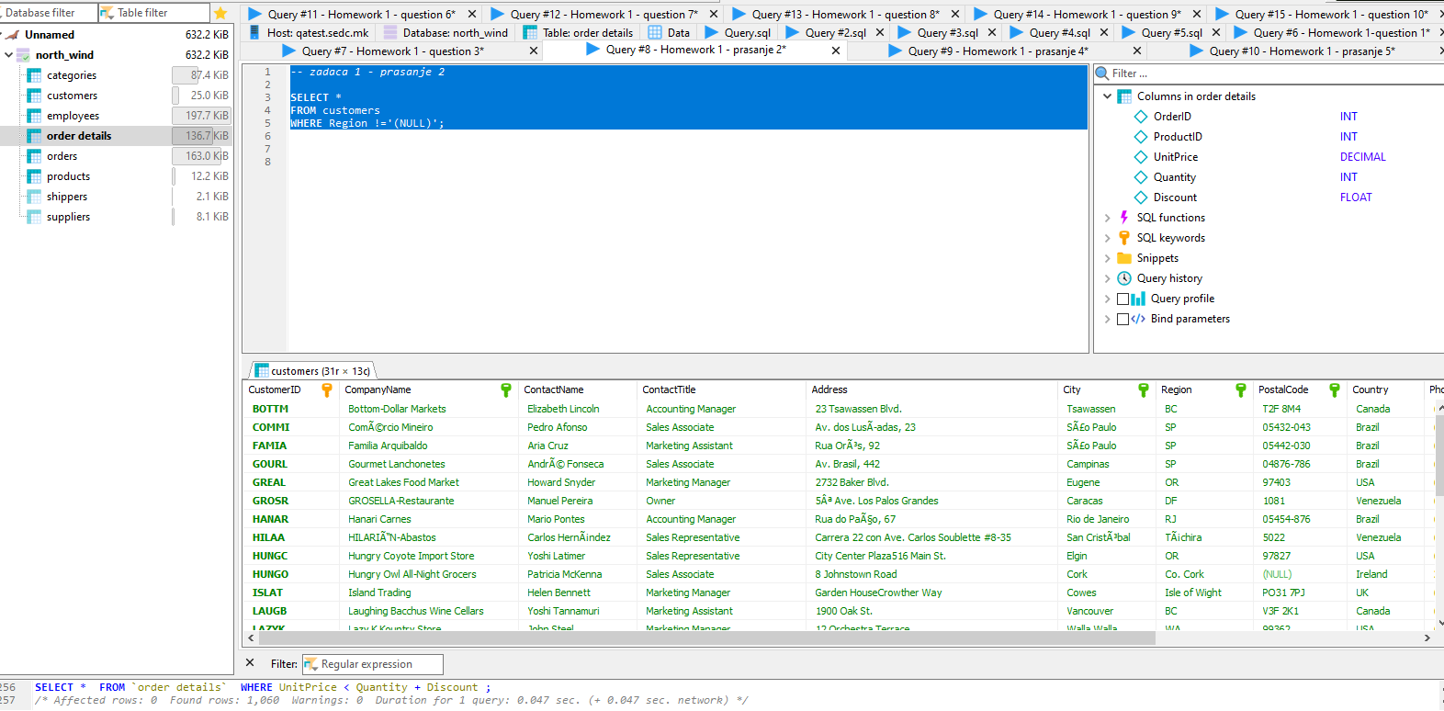

1. **Write a *query* to list Name and Surname for every employee that is from London.**

--zadaca 1 - prasanje 3

**SELECT** FirstName, LastName, City

**FROM** employees

**WHERE** City='London';

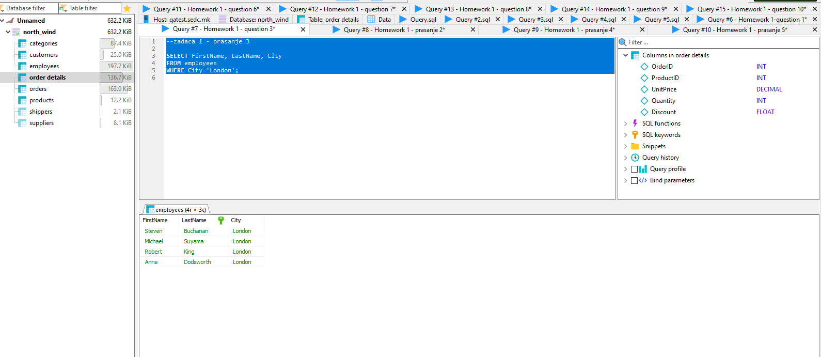

1. **Write a *query* to get list of all Order ID’s which are more than 20 in quantity.**

*-- zadaca 1 - prasanje 4*

**SELECT** *

**FROM** `order details`

**WHERE** Quantity >'20';

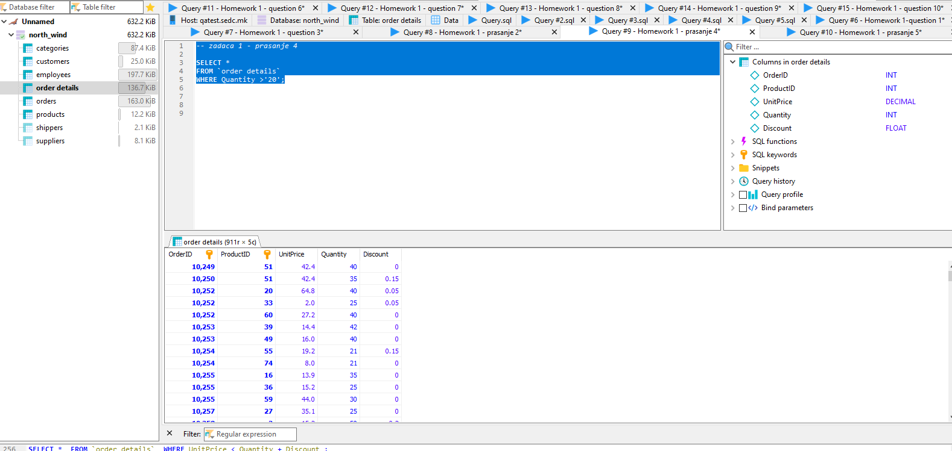

1. **Write a *query* to select the unit price and quantity of the products that have discount.**

--zadaca 1 - prasanje 5

**SELECT** ProductID, UnitPrice, Quantity, Discount

**FROM** `order details`;

**SELECT** ProductID, UnitPrice, Quantity, Discount

**FROM** `order details`

**WHERE** Discount >'0';

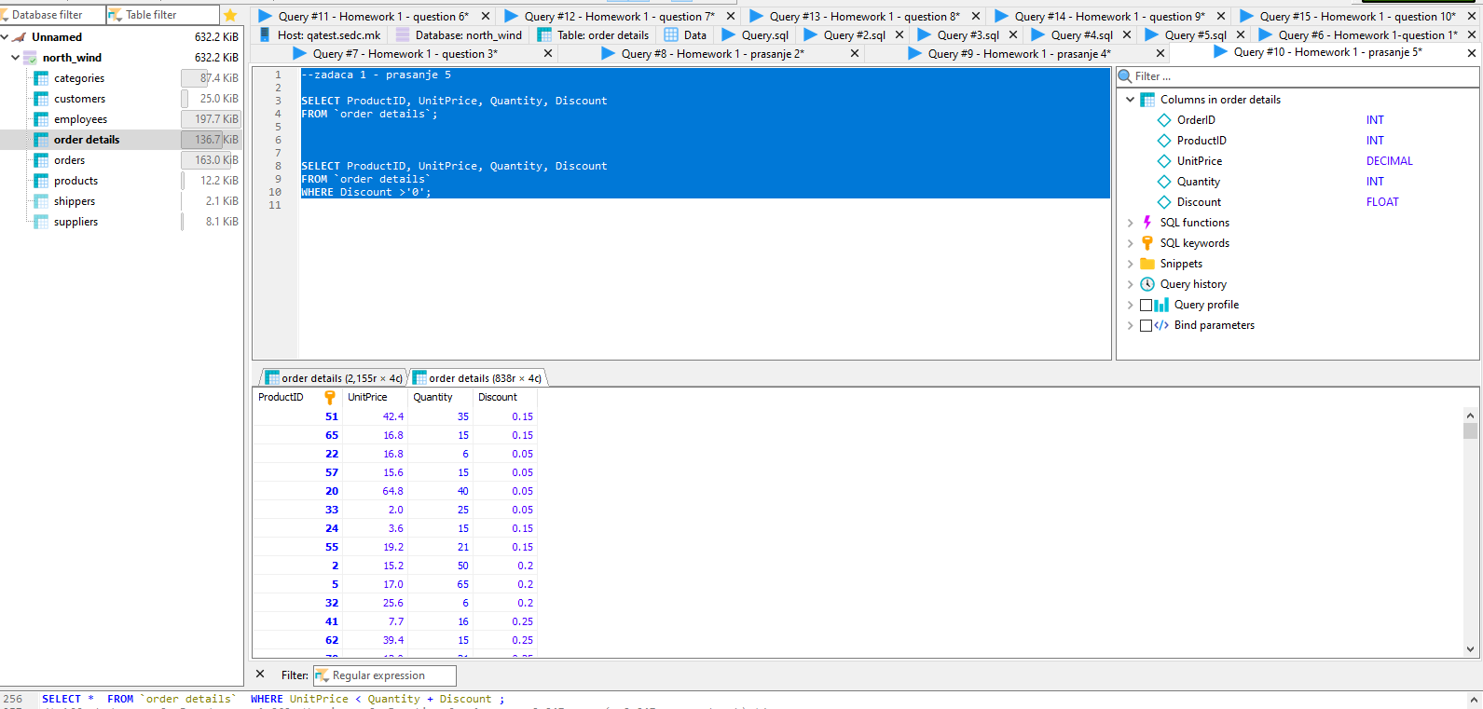

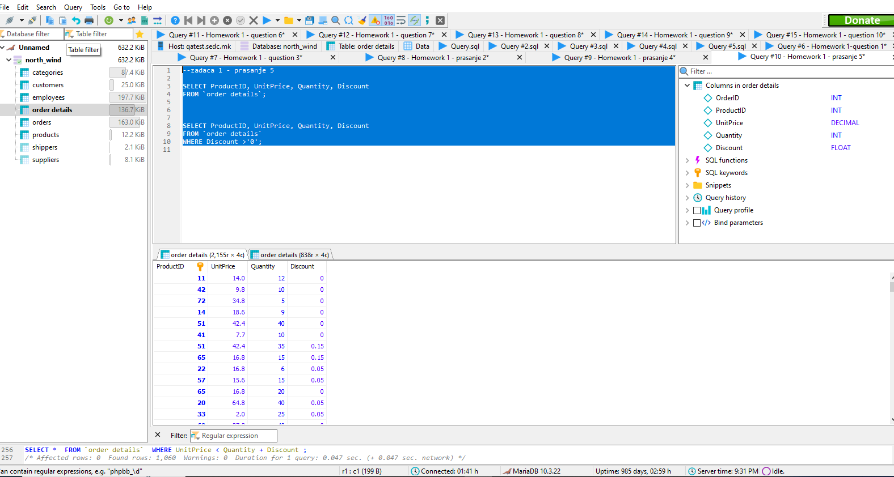

1. **Write a *query* to list only the product name (in product table) for all the items that are not in stock.**

*-- zadaca 1 - prasanje 6*

**SELECT** *

**FROM** products

**WHERE** UnitsInStock ='0';

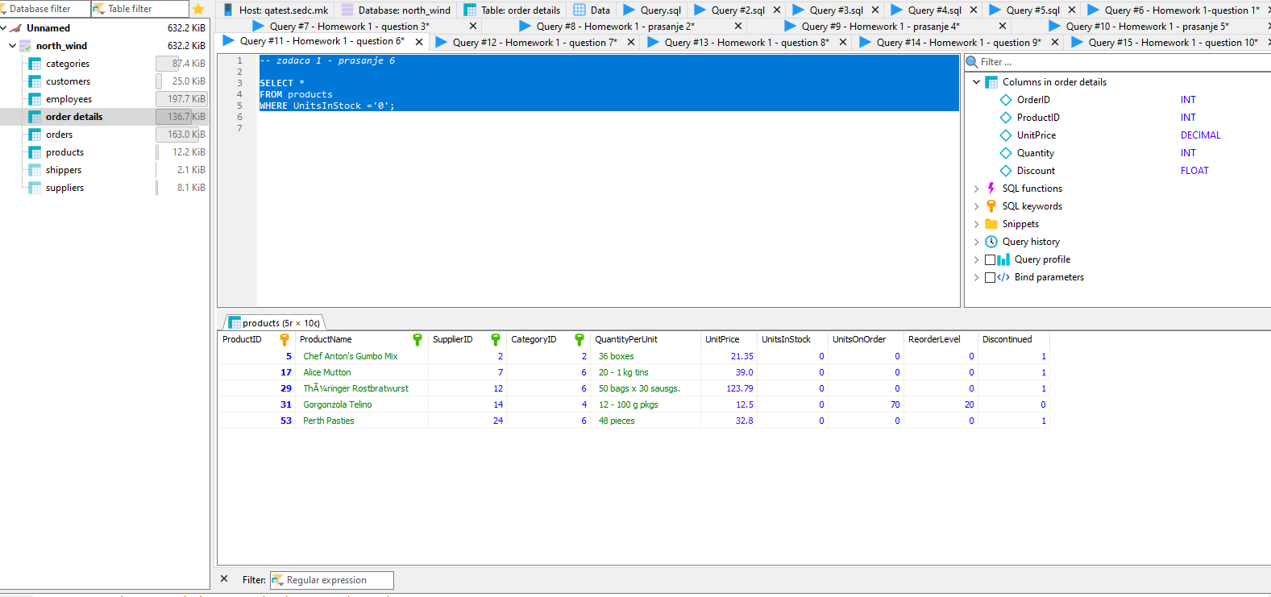

1. **Write a *query* to list all orders which have value of Shipped Via 2 or less.**

--zadaca 1 - prasanje 7

**SELECT** *

**FROM** orders

**WHERE** ShipVia <='2';

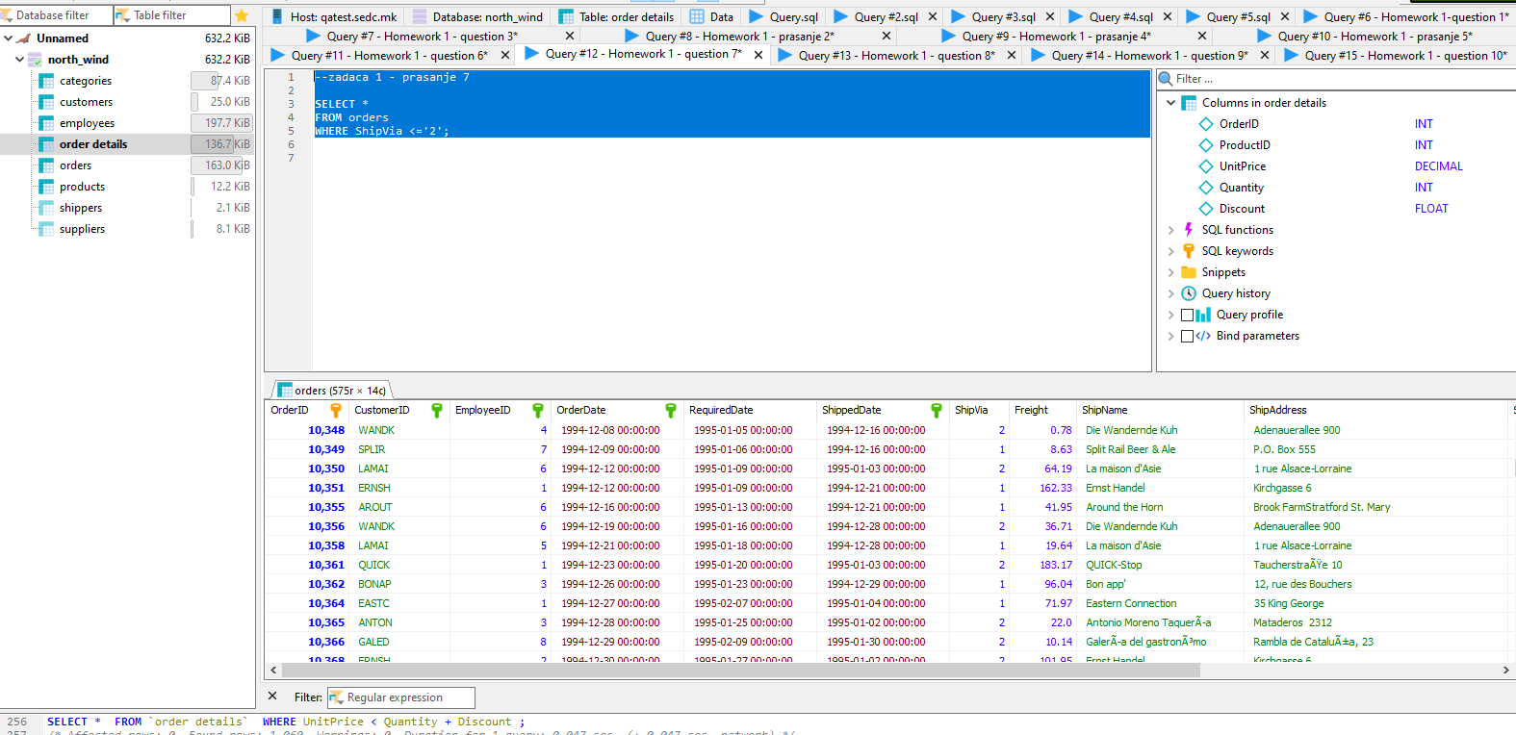

1. **Write a *query* to get all the products that have a price higher than 50.**

--zadaca 1 - prasanje 8

**SELECT** *

**FROM** products

**where** UnitPrice >'50';

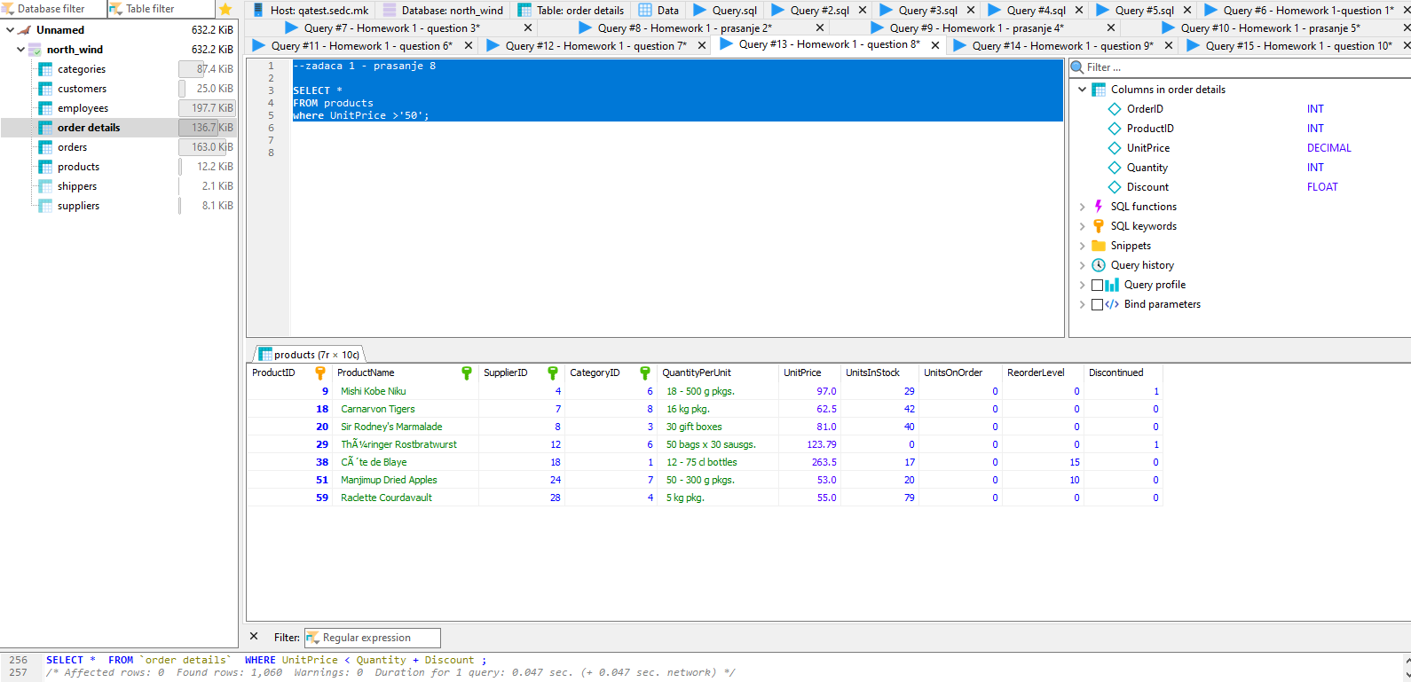

1. **Write a *query* to fetch the description in Categories where the category is Diary Products.**

--zadaca 1 - prasanje 9

**SELECT** *

**FROM** categories

**WHERE** CategoryName = 'Dairy Products';

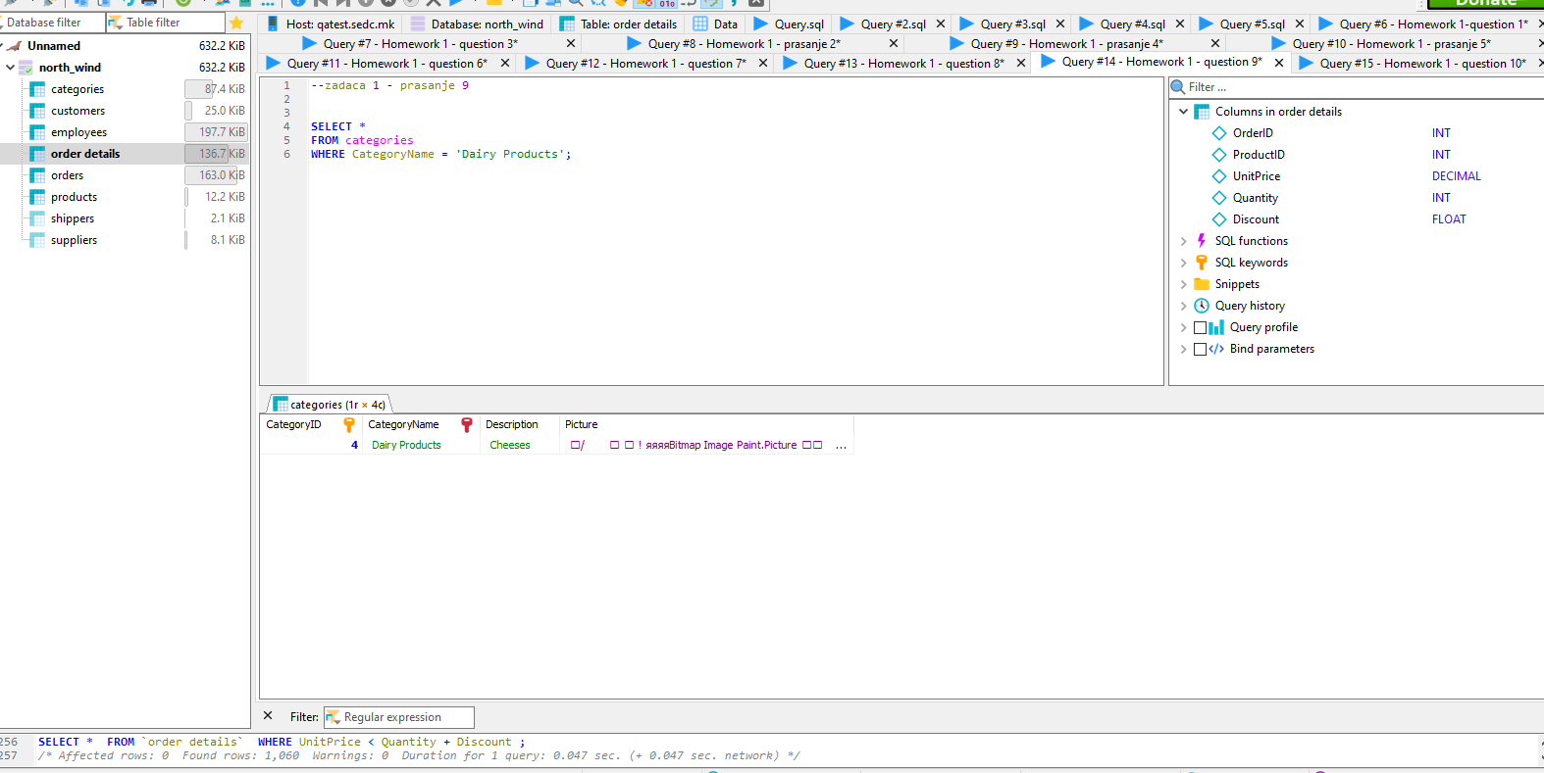

1. **Write the *query* that will list all the orders in which the Unit Price is smaller than the summation of Quantity and Discount in Order Details Tables.**

--zadaca 1 - prasanje 10

**SELECT** *

**FROM** `order details`

**WHERE** UnitPrice < Quantity + Discount;

